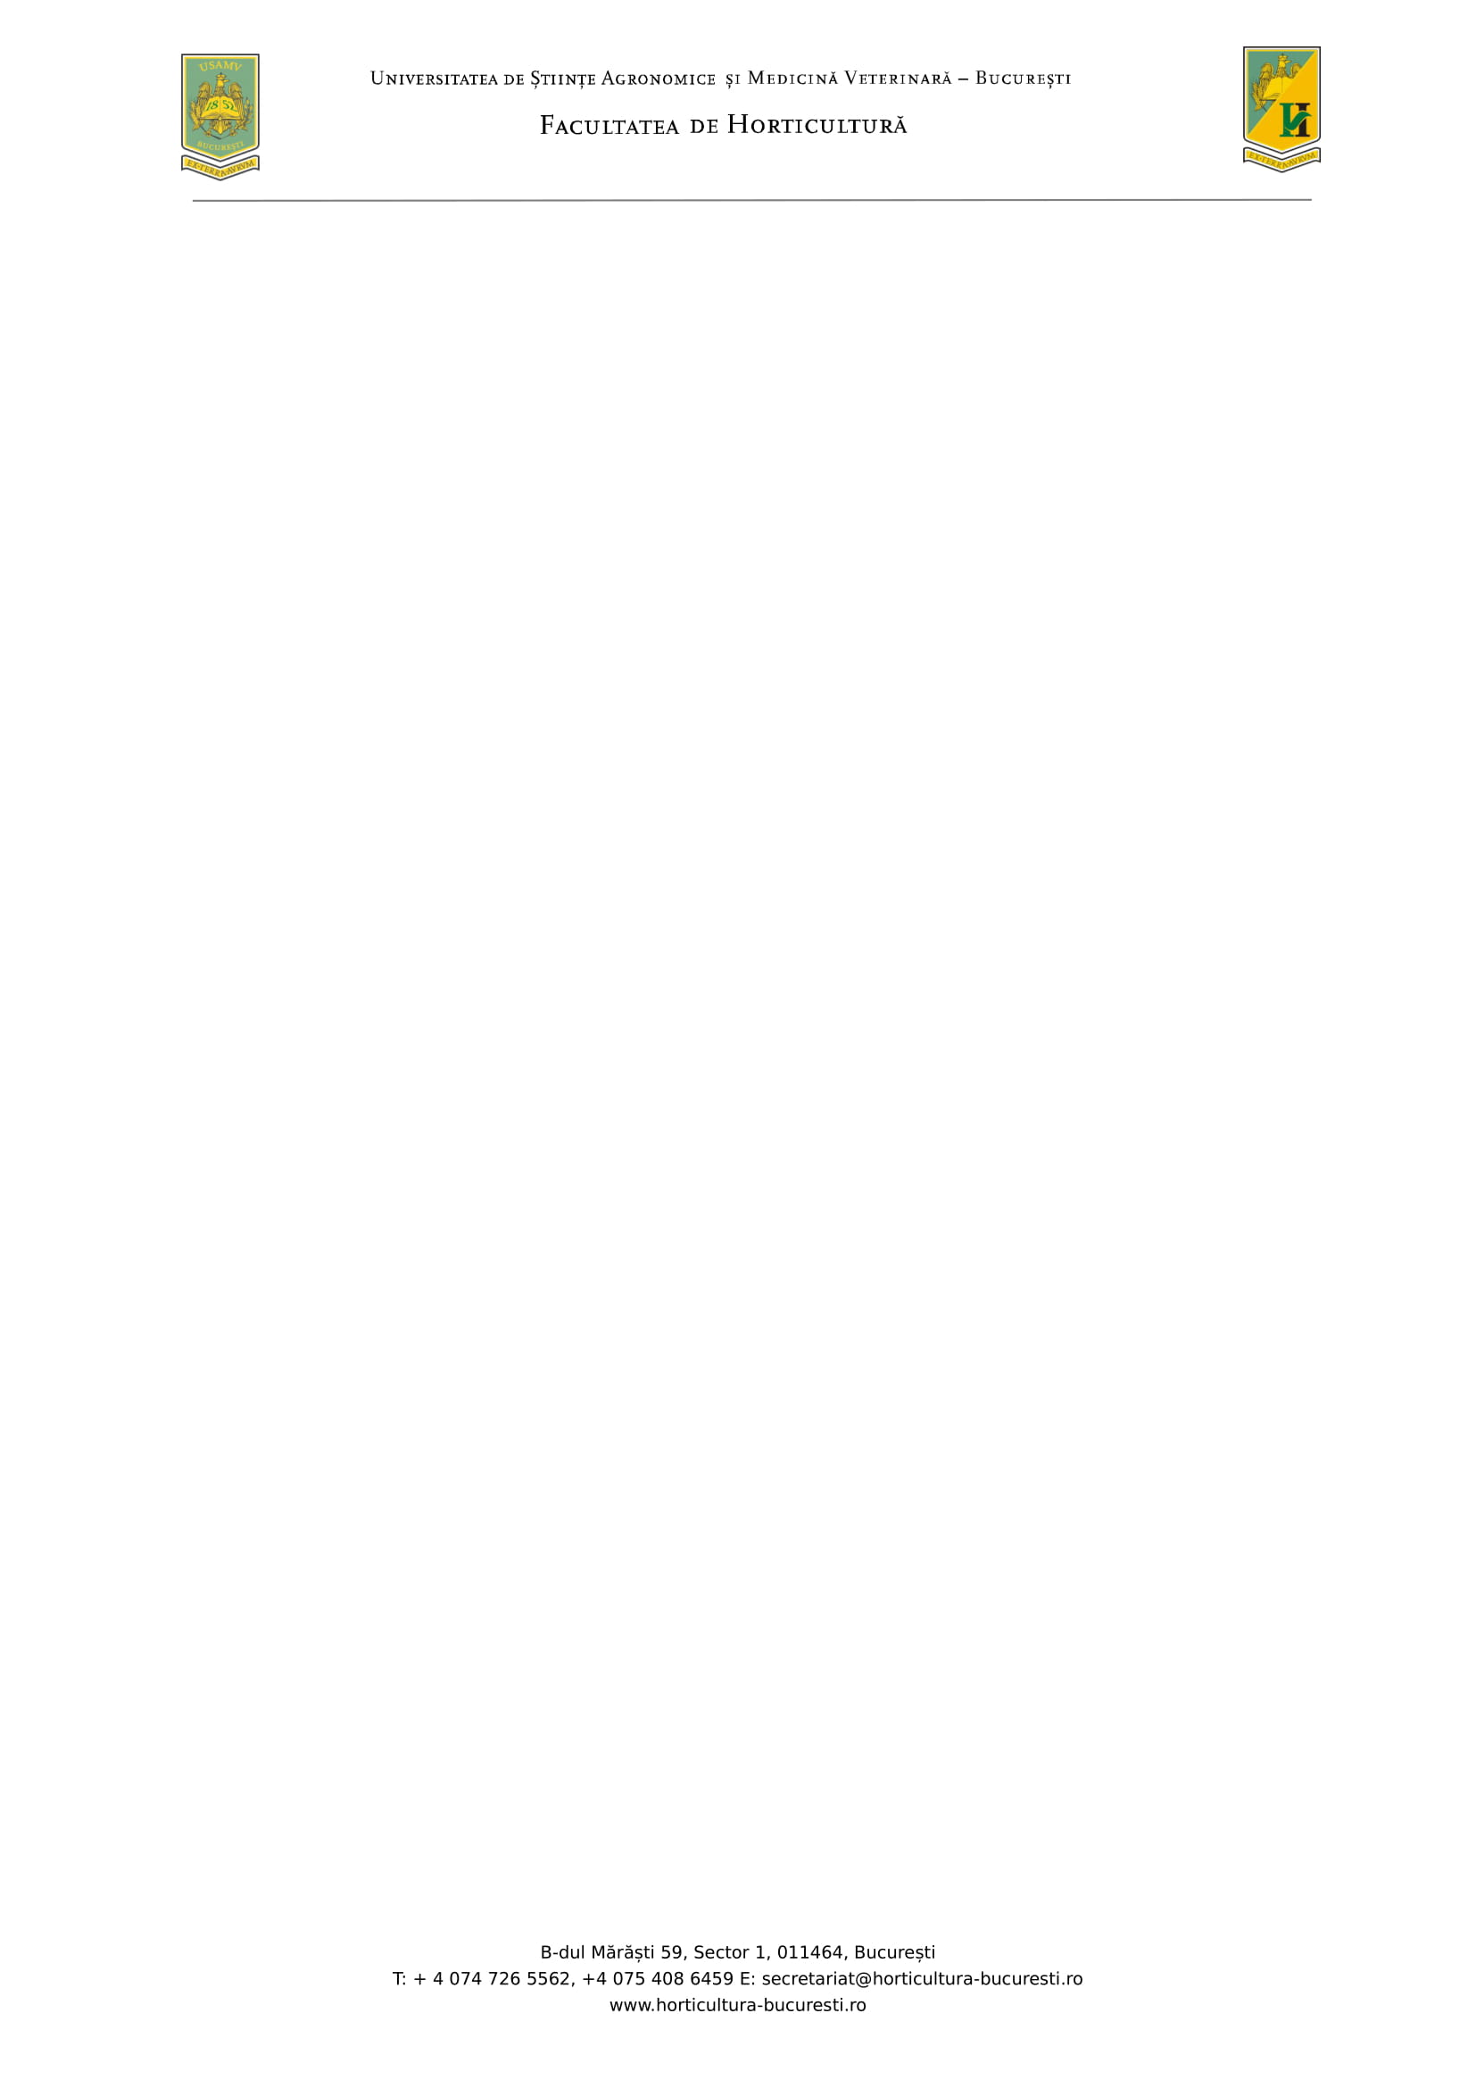

**REZULTATE FINALE**

**EXAMEN DE DIPLOMĂ**

**Program de studii: Peisagistică**

**Sesiunea septembrie 2024**

|  |  |  |  |
| --- | --- | --- | --- |
| **Nr. crt.** | **Nr. matricol UMS** | **Proba I/ oral**  **Nota** | **Proba II/ oral**  **Nota** |
| 1 | 964 | **9.20** | **9.00** |
| 2 | 965 | **8.60** | **7.60** |
| 3 | 968 | **10** | **9.40** |
| 4 | 980 | **8.00** | **8.20** |
| 5 | 981 | **8.60** | **8.60** |
| 6 | 991 | **10** | **9.00** |
| 7 | 992 | **8.20** | **7.80** |
| 8 | 994 | **8.00** | **6.60** |
| 9 | 999 | **8.80** | **9.40** |
| 10 | 1003 | **9.40** | **9.60** |

|  |  |  |  |  |  |
| --- | --- | --- | --- | --- | --- |
| **COMISIA:** | | |  | | |
| **Președinte:** | PROF. UNIV. DR. ADRIAN ASĂNICĂ | | |
| **Membri:** | | PROF. UNIV. DR. FLORIN TOMA | | |
|  | | PROF. UNIV. DR. MIHAELA GEORGESCU | | |
|  | | CONF. UNIV. DR. ELISABETA DOBRESCU | | |
|  | | Ș.L. DR. CLAUDIA FABIAN | | |
| **Secretar comisie:** | | Ș.L. DR. SIDONIA TEODORESCU | | |